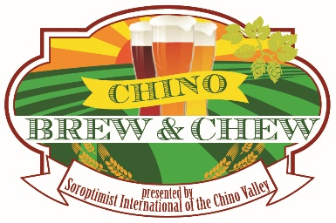
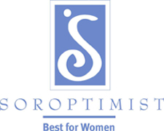
Soroptimist International
of the Chino Valley, Inc.
P.O. Box 547
Chino, CA 91708
www.si-chinovalley.org
www.soroptimist.org

Dear Community Friend:

Soroptimist International of the Chino Valley, Inc. (SICV) proudly announces its major fundraiser for 2020. “Chino Soroptimist Brew & Chew” will be hosted on Sunday, April 5, 2020 at the Chino Fairgrounds in Chino with over 1,000 attendees expected. With last year’s success, the Brew & Chew event will again provide beer tasting, gourmet food trucks and local merchant vendors for our guests to enjoy.

Showcase your business by becoming a sponsor for this very popular event. We have several levels in which your company can participate and reach out to our community. Levels of monetary sponsorships range from $100.00 to $2,500.00. (Please see the attached sponsorship form for the perks.) We have also enclosed a copy of our 2019 “Thank You” ad that appeared in the Chino Champion for your information. Deadline for sponsorship submittal is March 20, 2020.

This event will be advertised throughout the Inland Empire, particularly in areas of Chino, Chino Hills, Corona, Riverside, San Bernardino, Ontario, Pomona, Montclair and Claremont. Continued updates on this event may be viewed on Eventbrite, www.chinobrewandchew.eventbrite.com.

We appreciate your consideration in becoming an official sponsor. Please complete the Sponsorship Commitment Form and mail with your tax deductible contribution (as allowed by law) to Soroptimist International of the Chino Valley, Inc. We have provided a self-addressed envelope for your convenience. Thank you for your consideration and your valuable time. You can always contact us at 909-718-3225 or sichinovalley@soroptimist.net.

Soroptimist International of the Chino Valley, Inc. is non-profit organization under Internal Revenue Code, Section 501(c)(3). Our Tax ID number is 33-0577388. SICV, Inc. is a worldwide professional and business women’s organization dedicated to improving the lives of women and girls in our local community and throughout the world.

The local programs we are proud of is our “Stepping Up” for local 6th grade girls, anti-trafficking efforts, Live Your Dream, Dream It, Be It, and local high school scholarships. Please check out the website listed below for more information about all these programs and the other things we do.

Sincerely,

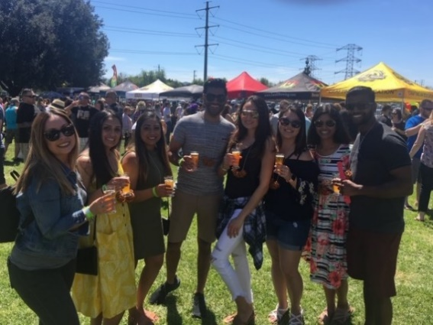
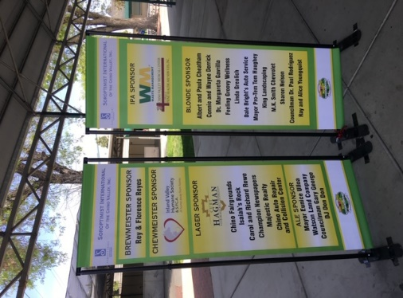

Brew & Chew Event Committee

sichinovalley@soroptimist.net

Attachments

Chino Soroptimist Brew & Chew 2018 & 2019

